Information Sheet - Head lice

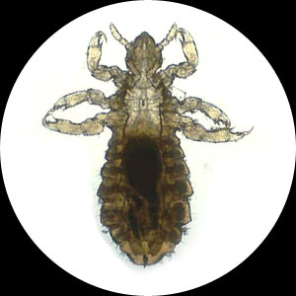

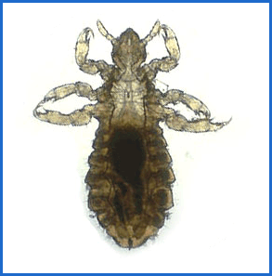

**Introduction**

There are many myths and legends about head lice and many treatment options both proven and not. It is important to control head lice in our school as it is uncomfortable for children when they have an infestation and often frustrating and expensive for families especially if reinfestation occurs.

Head lice are not only in schools. They spread wherever people work, play or live together. The Department of Education has a policy online for schools and parents to follow when head lice occur. Please read it in full at the following site –

<http://www.education.tas.gov.au/school/health/headlice/guidelines>

Other useful sites include -

Staying Healthy in Child Care – PDF Publication to be found at

<http://www.nhmrc.gov.au/guidelines/publications/ch43>

Department of Health and Human Services – Information on head lice for school use

[http://www.education.tas.gov.au/school/health/headlice](http://www.education.tas.gov.au/school/health/headlice/faq/lice.pdf)/faq/lice.pdf



**Parent responsibilities**

* Check their child’s hair regularly
* Apply an approved head lice treatment and remove eggs (nits) prior to return to school
* Advise school that their child has had head lice



**School responsibilities**

* Advise parents of an outbreak relevant to their child
* Seek support from the Department of Health and Human Services if there is a persistent outbreak at the school



**Department of Health and Human Services responsibilities**

* Provide information to schools and parents as required



**What do head lice look like and how do I know if my family has them?**

Head lice are small insects that have no wings. They hide in the hair and come down to the scalp to feed. They are difficult to see and move very quickly. A magnifying glass and good light can help you find them. Probably the best way to find them is to apply hair conditioner to the hair covering it well from root to tip. The conditioner slows down the lice.

The other sign of head lice is the presence of eggs (often called nits). Head lice eggs are white and very small. You can tell they are different from dandruff because they stick firmly to the hair. Head lice usually lay their eggs within 1.5cm of the scalp so eggs that are further than 2cm from the scalp are likely to be either hatched or dead but still should be removed.



**I don’t want head lice! How do I prevent my family getting them?**

Head lice can’t fly they can only crawl. They are spread by close contact and they don’t live long off the body. Avoid contact with other people’s hair or things that have recently been in contact with someone else’s hair. Don’t share things like brushes, combs, hats, bathing caps and hair ties. Keep hair short or braid long hair firmly. Brushing hair really well, a hundred strokes with the hairbrush each day, is a good idea as it cripples head lice! This makes them less active but doesn’t get rid of them. Another tip is to check school-age children daily. It’s easier to get rid of a few head lice than a lot!



**What do I do if my child has head lice?**

If your child gets head lice, check everyone in the household and treat everyone you find has head lice. Not everyone feels itchy if they have head lice. Adults don’t always itch the way most children do but, if they aren’t treated, they can be the cause of children getting head lice again. Beards are another place where head lice can be found. The Family, Child and Youth Health Service have information sheets to help you with questions about what you need to do. It’s not a good idea to use head lice treatments any more often than you need to. So, first of all, make sure your family actually has head lice!

To get rid of head lice you can use one of the various chemical treatments or use the hair conditioner combing method. It is wise not to use chemical lotions on children younger than two, women who are breastfeeding or pregnant, or people with sensitive skin. Every few years a different base is recommended to try to avoid head lice becoming resistant to the chemicals. Follow the instructions CLOSELY. If you are sure you have followed the directions correctly and you still find live lice after using the treatment, do not continue to use that product. Talk to your local Family and Child Health Nurse or pharmacist about using a product that contains a different chemical or try the hair conditioner combing method.

No chemical head lice treatment kills all the eggs so it is important to remove the eggs as well – the easiest way is with your fingernails – and to repeat the chemical treatment in seven days. Do not keep using products that contain a lice-killing chemical.

The hair conditioner combing method can be successful but does take more time. Hair conditioner makes it easier to remove the head lice and eggs but it doesn’t kill them. For this reason, you need to use the method every second day for a week, then twice weekly for two weeks and weekly for two months. Wet the hair really well and then squeeze all the moisture out of it with a towel. Put a large amount of conditioner on the hair and comb out any tangles with a normal comb. Using a fine-tooth comb, go through the hair, small amounts at a time, combing from the scalp to the hair ends and then wiping lice off the comb (on to a tissue or towel) before starting on the next section of hair. Repeat combing each section of hair five times. When combing is finished the conditioner can be washed off. Finally it’s important to remove all eggs – using your fingernails is easiest.

In most instances, it’s not necessary to do anything to clean carpets or bedding but it’s a good idea to wash hairbrushes in hot soapy water and dry them in the sun.

Head lice can make children’s scalps itchy. If head lice are left unchecked, the child will scratch the scalp until it bleeds and gets sore and it could become infected.



**Myths**

* Head lice cause disease - Head lice are a nuisance but they are not known to carry disease.
* People who aren’t very clean get head lice - Head lice seem to particularly like clean hair.
* Children always get head lice at school - Head lice are always about in the community. Parents and other relatives can unintentionally reinfest family members because they think that not being itchy means no head lice!
* No itch means no head lice - Adults don’t seem to get itchy from head lice the way most children do.